43.38: a) From Table (43.3), the absorbed dose is 0.0900 rad. b) The energy absorbed is each proton has energy 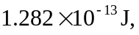 so the number absorbed is 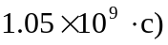 The RBE for alpha particles is twice that for protons, so only half as many, 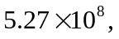 would be absorbed.

